**Session 9 (unit-5): Operator Overloading**

1. **Use the concept of Operator overloading to overload ‘-’ operator in order to subtract two complex numbers.**

#include <iostream>

using namespace std;

class Complex

{

private:

float real;

float imag;

public:

Complex(): real(0), imag(0){ }

void input()

{

cout << "Enter real and imaginary parts respectively: ";

cin >> real;

cin >> imag;

}

Complex operator - (Complex c2)

{ Complex temp;

temp.real = real - c2.real;

temp.imag = imag - c2.imag;

return temp;

}

void output()

{

if(imag < 0)

cout << "Output Complex number: "<< real << imag << "i";

else

cout << "Output Complex number: " << real << "+" << imag << "i";

}

};

int main()

{

Complex c1, c2, result;

cout<<"Enter first complex number:\n";

c1.input();

cout<<"Enter second complex number:\n";

c2.input();

result = c1 - c2;

result.output();

return 0;

}

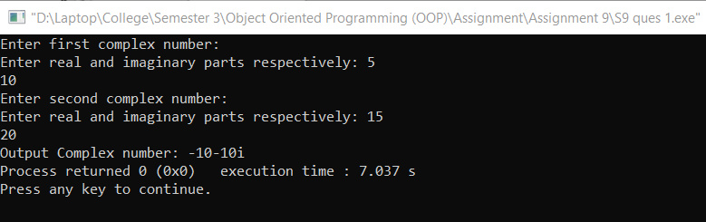

**2. Use the concept of Operator overloading to redefine the use of ‘++’ so that when this is encountered, then the value of variable increases by 100 and not by 1.**

#include<iostream>

using namespace std;

class add

{

private:

int x;

public:

add(): x(100){}

void operator ++()

{

x = x + 100;

}

void display()

{

cout << "Enter the Number: ";

cin >> x;

x = x + 100;

cout << "Sum = " << x <<endl;

}

};

int main()

{

add ob;

ob.display();

++ ob;

ob.display();

return 0;

}

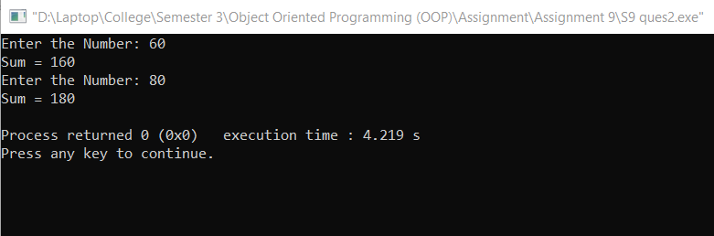

**3.   WAP that accepts two objects of time class in hh:mm:ss format and is finally add the two times and display the addition result.**

**Example: class time: int hrs, int min, int sec**

**Obj1: 09:22:35**

**Obj2: 02:45:53**

**Overload ‘+’ operator to add two objects to get total time.**

#include <iostream>

using namespace std;

class Time

{

int hrs,minute,sec;

public:

time(int h, int m, int s)

{

hrs = h;

minute = m;

sec = s;

}

void setTime()

{

cout << "\n Enter the hour(0-11) ";

cin >> hrs;

cout << "\n Enter the minute(0-59) ";

cin >> minute;

cout << "\n Enter the second(0-59) ";

cin >> sec;

}

void operator +(Time t)

{

int h, m, s;

s = sec + t.sec;

m = minute + t.minute+(s/60);

h = hrs + t.hrs+(m/60);

m=m%60;

s=s%60;

cout<<"\n The added time is: "<<h<<":"<<m<<":"<<s;

}

};

int main()

{

Time t1,t2;

cout << "\n Enter the first time ";

t1.setTime();

cout << "\n Enter the second time ";

t2.setTime();

t1 + t2; //adding of two time object using '+' operator

}

